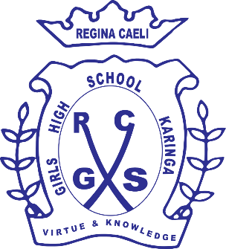**REGINA CAELI GIRLS HIGH SCHOOL - KARINGA**

**233**

**Chemistry**

**Form 1**

**Term II opener 2022**

**Time: 2½** **Hrs**

**Name…………………………………………. Adm……………….. Class………..**

**Instructions**

* **Write your name, class and admission number as required.**
* **This paper consists of …… printed pages.**
* **Ensure all the requisite pages are printed.**
* **Answer all questions in the spaces provided.**
* **All answers should be written in English.**
* **Use blue or black pen.**

**EXAMINER’S USE ONLY**

|  |
| --- |
| **100** |

1. a.Define the term chemistry. ( 1mk)

……………………………………………………………………………………………………………………………………………

……………………………………………………………………………………………………………………………………………

b.State three importance of studying chemistry as a subject. (3mks)

……………………………………………………………………………………………………………………………………………

……………………………………………………………………………………………………………………………………………

1. Explain why laboratory apparatus are made of glass. ( 2mks)
2. State any tree differences between a luminous flame and non –luminous flame. (6mks)

|  |  |
| --- | --- |
| Luminous flame | Non-luminous |
|  |  |
|  |  |
|  |  |

b.The diagram below shows a Bunsen burner when in use.

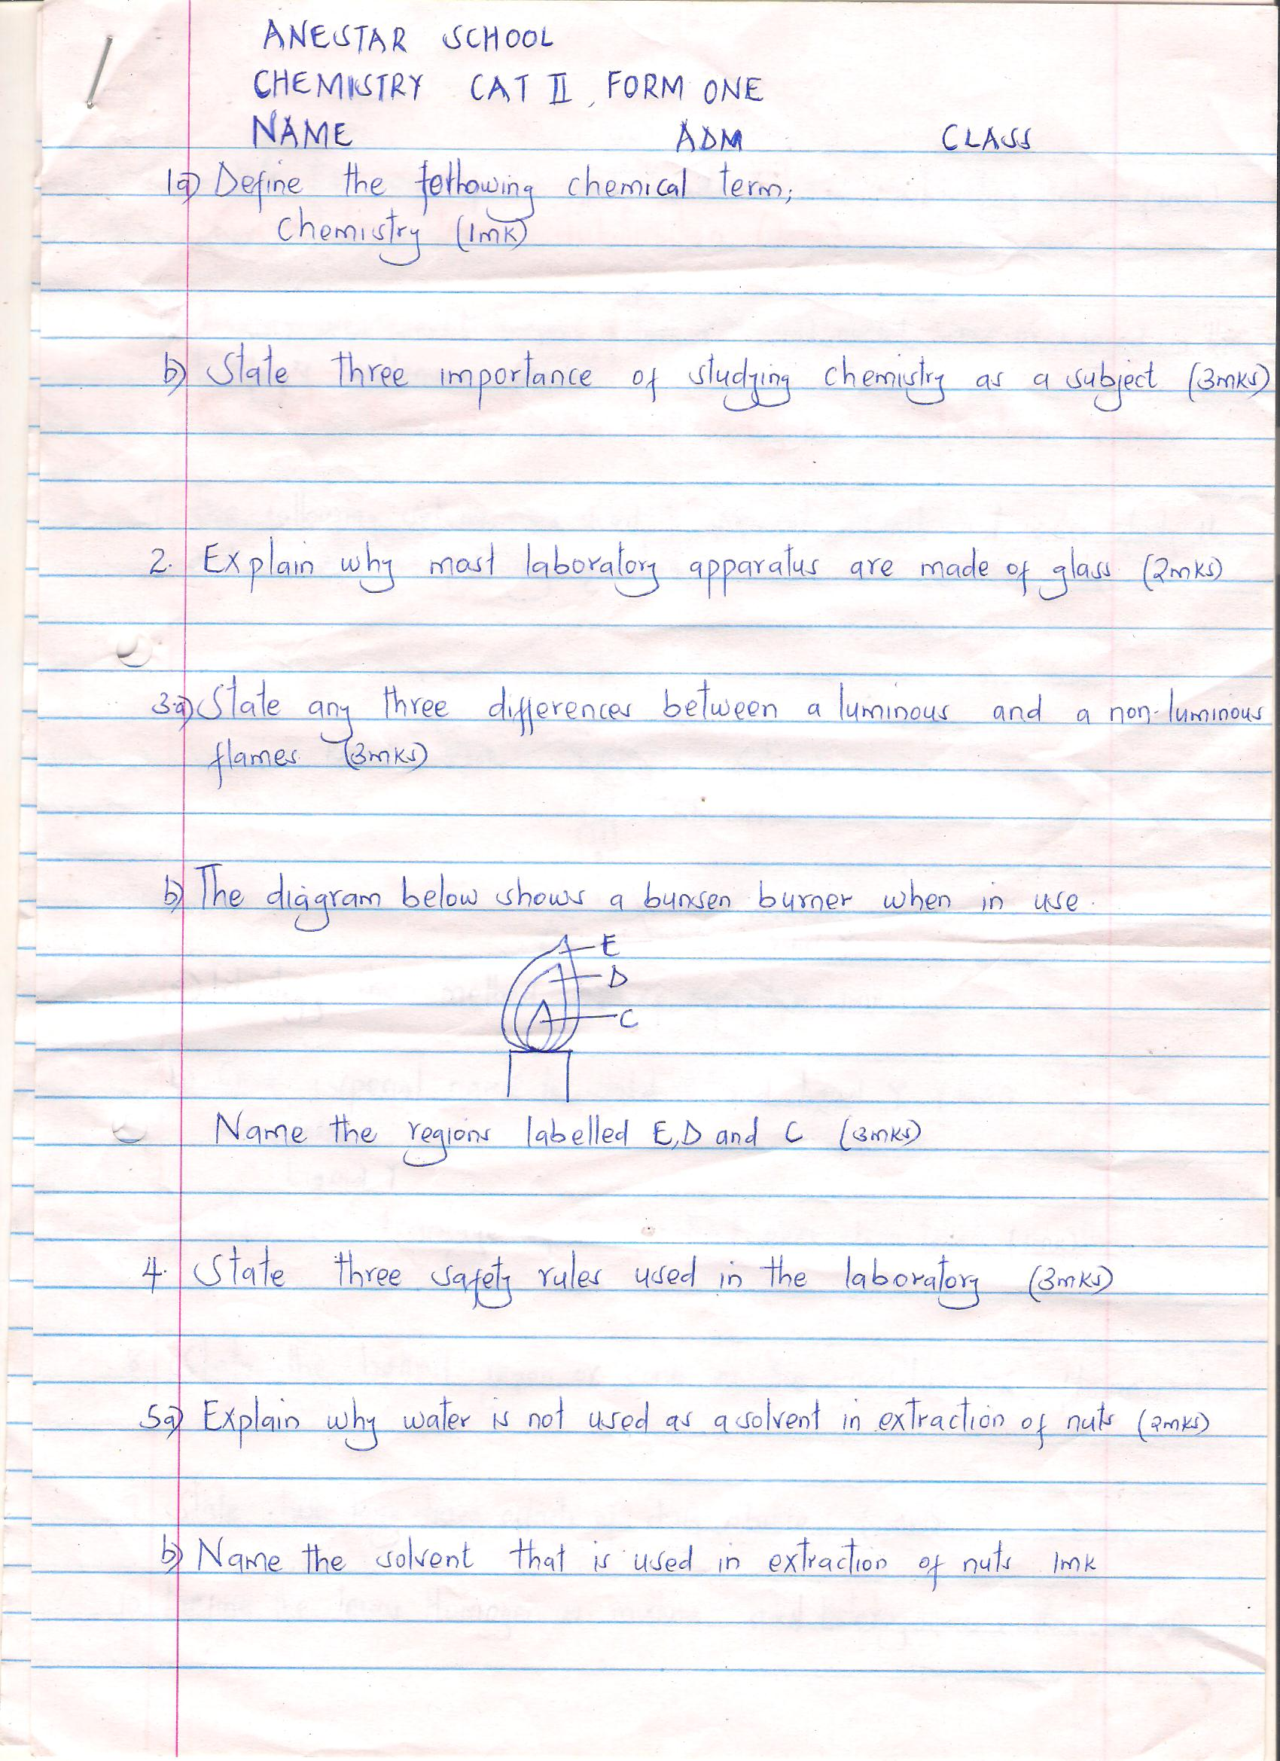

Name the regions labeled E, D and C ( 3mks)

E………………………………………….

D…………………………………………..

C……………………………………………..

1. State three safety rules used in the laboratory. (3mks)

………………………………………………………………………………………………………………………

1. a.Explain why water is not used as a solvent in extraction of nuts. ( 2mks)

……………………………………………………………………………………………………………………………………………

b.Name the solvent that can be used in extraction of nuts. ( 1mk )

……………………………………………………………………………………………………………………………………………

1. a .Define the term sublimation. (1mk)

……………………………………………………………………………………………………………………………………………

b.state two substances that undergoes sublimation. ( 2mks)

……………………………………………………………………………………………………………………………………………

1. The following set up was used to separate sand and water .study it and answer the questions that follows.

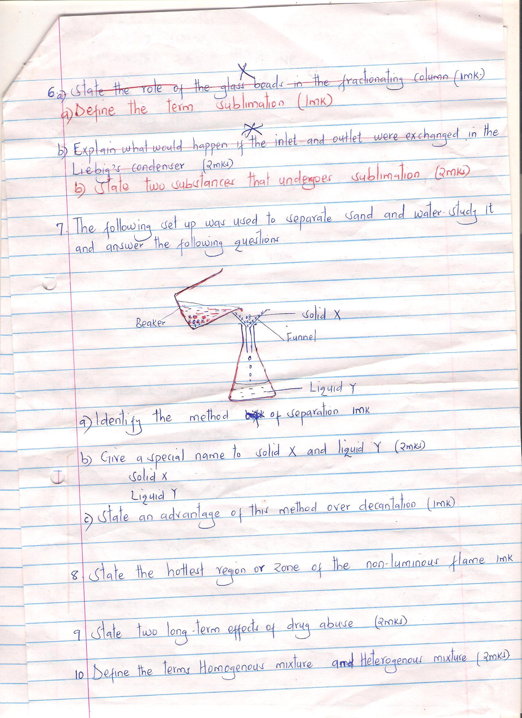

1. Identify the method of separation. (1mk)

……………………………………………………………………………………………………………………………………………

1. Give a special name given to solid X and liquid Y. (2mks)

Solid X……………………………………

Liquid Y………………………………..

1. State an advantage of this method over decantation. ( 1mk)

……………………………………………………………………………………………………………………………………………

1. What is the name given to the hottest zone of non luminous flame? (1mk)

……………………………………………………………………………………………………………………………

1. State two long term effects of drug abuse. (2mks)

……………………………………………………………………………………………………………………………………………

……………………………………………………………………………………………………………………………………………

1. Define the terms homogeneous mixture and heterogeneous mixture. ( 2mks)

……………………………………………………………………………………………………………………………………………

1. The diagram below shows the apparatus commonly used in a laboratory.

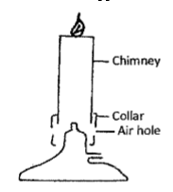

(i) Name the apparatus. (1mark) .............................................................................................................................................................................. .............................................................................................................................................................................. (ii) State the function of the parts labeled in the above apparatus.

a) Chimney. (1 mark) .............................................................................................................................................................................. ..............................................................................................................................................................................

b) Collar (1mark) .............................................................................................................................................................................. ..............................................................................................................................................................................

c) Air hole. (1 mark) .............................................................................................................................................................................. ..............................................................................................................................................................................

(iii)What is a flame? (lmark) .............................................................................................................................................................................. ..............................................................................................................................................................................

(iv) The following diagrams represent the two types of flames.

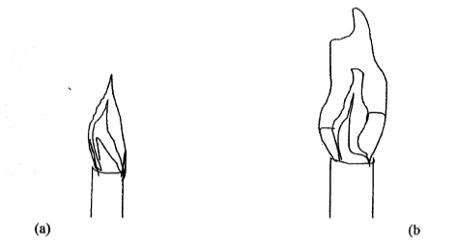

a) Identify the flames (a) and (b) (2marks) a) .......................................................................................................................................................................

b) .......................................................................................................................................................................

v) Which type of the flames identified above is preferred for heating? Give a reason for your answer. (2marks) .............................................................................................................................................................................. .............................................................................................................................................................................. .............................................................................................................................................................................. ................................................................................................................................................................

12. a) What is a drug? (1 mark) .............................................................................................................................................................................. ................................................................................................................................................................

b) what is drug abuse (2mark )

……………………………………………………………………………………………………….

c) Name two commonly legal abused drugs (2 marks)

...........................................................................................................................................................................................................................................................................................................................................

13. Describe briefly how a mixture of sand and sodium chloride can be separated (3 marks) .............................................................................................................................................................................. .............................................................................................................................................................................. .........................................................................................................................................................

..............................................................................................................................................................................

..............................................................................................................................................................................

14. The diagram below shows a chromatogram of pure dyes W, X andY. It also contains that of an impure substance K.

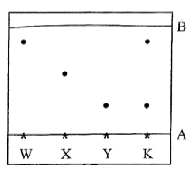

1. Name lines A and B (2marks)

A ............................................................................................

B ............................................................................................

(b) Identify which. Pure dyes substance K contain. (1mark) .............................................................................................................................................................................. ................................................................................................................................................................

(e) Which two properties of the component of the mixture facilitate separation? (2 marks)

.............................................................................................................................................................................. ................................................................................................................................................................

(d) Normally line A is drawn using a pencil and not ink. Explain why the pencil is preferred to ink.(1mark) .......................................................................................................................................................................

(e) State one application of chromatography. (1 mark) .............................................................................................................................................................................. ................................................................................................................................................................

10. Give two reasons why laboratory apparatus are made of glass. (2 marks) .............................................................................................................................................................................. ................................................................................................................................................................

..........................................................................

1. The diagram below shows the relationship between the physical states of matter.Study it and answer the questions that follows.

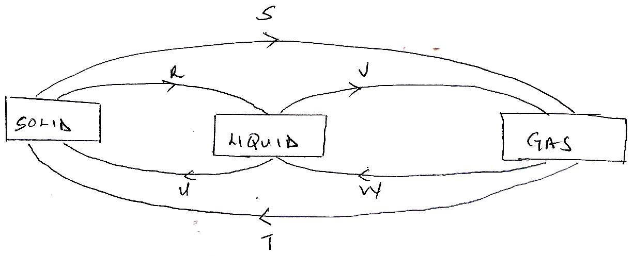

1. Identify the process R,V,W and U ( 4 mks)

R…………………………………………

V…………………………………………

W………………………………………..

U………………………………………….

1. Name three substances which can undergo the process represented by process S and T.( 3mks)

………………………………………

……………………………………..

The table below shows liquids that are miscible and those that are immiscible

Liquid L3 L4

L1 Miscible Miscible

L2 Miscible immiscible

1. Use the information given to answer the questions that follow.

Name the method that can be used to separate L1 and L3 from a mixture of the two. ( 1mk)

……………………………………………………………………………………………

1. Draw and name an apparatus that can be used to separate a mixture of L2 and L4.( 3mks)
2. Name three sources of heat beside Bunsen burner in the laboratory.( 3mks)

………………………………………………………

…………………………………………………………

…………………………………………………………..

1. After use a non-luminous flame should be put off or adjusted to a luminous flame. Explain. (2mks)

………………………………………………………………………………………………………

………………………………………………………………………………………………………

1. Name three apparatus that are used to measure accurate volume of liquids. ( 3mks)

………………………………………………………………………………..

………………………………………………………………………………..

………………………………………………………………………………….

1. Name the method you would use to separate the following mixtures.
2. Sand and ammonium chloride ( 1mk)

……………………………………

I)Oil and Water. ( 1mk)

…………………………………………

ii)Kerosene and crude oil ( 1mk)

……………………………………………

iii)Salt and water. ( 1mk)

……………………………………………

b)State the functions of the following apparatus as used in the laboratory.

Spatula (1mk)

…………………………

Pine-clay triangle ( 1mk)

…………………………..

Wire gauze ( 1mk)

…………………………………

c) Draw and state the use of a deflagrating spoon.( 3mks)

d) State the two causes of accidents in a Chemistry laboratory.( 2mks)

1. Define the following terms

Solvent extraction ( 2mks)

………………………………………………………………………………………………………..

………………………………………………………………………………………………………….

Saturated Solution 2mks)

………………………………………………………………………………………………………….

………………………………………………………………………………………………………….

1. The diagram below represents a paper chromatogram for three brands of juices suspected to contain banned food colourings.

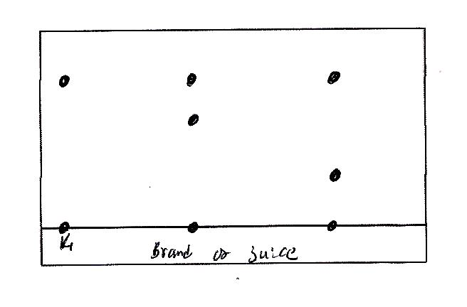

The results showed the presence or banned food colourings in L and M only.

1. On the same diagram

i)Circle the spots which show the banned food colourings. ( 2mks)

ii) Show the solvent front and the baseline. ( 2mks)

1. State two factors that determine the position where the pigments are deposited in the paper chromatogram from the point of origin. ( 2 mks)

………………………………………..

…………………………………………